**A Project Report**

**On**

**“ONLINE SHOPPING SITE”**

Submitted by:

Gowthaman.D & 19MEC24024

**Under the Guidance of**

Prof. Puneet

Department of Computer Science

**24/03/2022**



**Department of Computer Science**

**St. Joseph’s College (Autonomous)**

**Bengaluru**

**Certificate**



This to certify that **Gowthaman D (19MEC24024)** have successfully completed the project titled “**ONLINE SHOPPING SITE**” at St. Joseph’s College (Autonomous) under the supervision and guidance in the fulfilment of requirements of Fifth semester, Bachelor of Science (Computer Science) of Bengaluru City University, Bengaluru.

* Prof. Puneet

Prof. Sandhya

Head of the Department

Computer Science

**Certificate**



This to certify that **Joel X(19MEC24010) , Yaseen A (19MEC24012), Valan Bories (19MEC24018), Gowthaman D (19MEC24024)** have successfully completed the project titled **“ONLINE SHOPPING SITE”** at St. Joseph’s College (Autonomous) under the supervision and guidance in the fulfilment of requirements of Fifth semester, Bachelor of Science (Computer Science) of Bengaluru City University, Bengaluru.

* Prof .Puneet

Prof. Sandhya

Head of the Department

Computer Science

**INDEX:**

|  |  |  |
| --- | --- | --- |
| **SI.NO** | **CONTENT** | **PG.NO** |
| 1. | Abstract | **1** |
| 2. | Introduction | **1** |
| 3. | Study of Existing System | **2** |
| 4. | Study of proposed System | **2** |
| 5. | System Requirements | **5** |
| 6. | Website Navigation flow chat | **8** |
| 7. | Design/Screenshots of the Webpages | **11** |
| 8. | Coding of the Webpage | **15** |
| 9. | Future Enhancement of the Website | **47** |
| 10. | Conclusion | **48** |
| 11. | Bibliography/ References | **48** |

**ABSTRACT:**

This project is a web based Online shopping system. This project is an attempt to provide the advantages of online shopping to customers of a real shop. It helps buying the products in the shop anywhere through internet by using any device. Thus the customer will get the service of online shopping and home delivery from his favourite shop. This system can be implemented to any shop in the locality or to multinational branded shops having retail outlet chains. If shops are providing an online portal where their customers can enjoy easy shopping from anywhere, the shops won’t be losing any more customers to the trending online shops. Since it is easily accessible and always available. The project that I have taken is also in this category which is used in our daily life whenever we want to purchase some items we can easily get them.

**INTRODUCTION:**

**Online shopping** is the process whereby consumers directly buy goods, services etc. from a seller interactively in real-time without an intermediary service over the internet. Online shopping is the process of buying goods and services from merchants who sell on the Internet. Since the emergence of the World Wide Web, merchants have sought to sell their products to people who surf the Internet. Shoppers can visit web stores from the comfort of their homes and shop as they sit in front of the computer. Consumers buy a variety of items from online stores. In fact, people can purchase just about anything from companies that provide their products online. Books, clothing, household appliances, toys, hardware, software are just some of the hundreds of products consumers can buy from an online store. can search through multiple stores at the same time, comparing material quality, sizes and pricing simultaneously. Shopping via the internet eliminates the need to sift through a store's products with potential buys like pants, shirts, belts and shoes all slung over one arm.

**Objective:**

The objective of project on Online Shopping Portal is to developing a GUI based automated system, which will cover all the information Related to the all products which is used in our daily life. For example – Mobiles Phones, Laptops, Clothes, Books, Electronic Items and many more. So by this GUI based automated system a user want to purchase something then it only a click away to purchase these products.

**SYSTEM ANALYSIS:**

• This system is all about the converting the shopping

system from manual to online.

• Customer can buy products online after login to the site.

• Administrator is adding product to database.

• Administrator can edit or delete the products

from the database.

• After buying and making payment the products are

send to customers address that he has given.

• Customer can write feedback for the product or services.

• Admin can see daily sell and feedback given by customer.

• Administrator is adding the delivery report to the database.

• Both admin and customer can see the delivery report**.**

**EXISTING SYSTEM** :

The current system for shopping is to visit the shop manually and from the available product choose the item customer want and buying the item by payment of the price of the item.

* It is less user-friendly.
* User must go to shop and select products.
* It is difficult to identify the required product.
* Description of the product limited.
* It is a time consuming process
* Not in reach of distant users.

**PROPOSED SYSTEM**:

Online shopping tries to enhance access to care and improve the continuity and efficiency of services. Depending on the specific setting and locale, case managers are responsible for a variety of tasks, ranging from linking clients to services to actually providing intensive shopping and delivery services themselves.

**Features of Proposed System:**

* The proposed system is flexible both for the administrators and the customers visiting the website.
* The proposed system provides a unique platform for different silk vendors to interact using the same platform.
* The proposed system allows easy promotion of the site through emails and newsletters.
* The proposed system gives information about the delivery and present status of their orders.
* Management of data is easy.
* Security is provided wherever necessary.

**MAIN OBJECTIVE:**

• To shop wile in the comfort of your own home, without having to step out of the door.

• sell at lower rate due to less overhead.

• provide home delivery free of cost.

• No wait to see the products if someone else is taking that.

**SCOPE:**

This product has great future scope. Online shopping Internet software developed on and for the Windows and later versions environments and Linux OS. This project also provides security with the use of Login-id and Password, so that any unauthorized users cannot use your account. The only Authorized that will have proper access authority can access the software.

**Need For Proposed System:**

The online shopping (HOME SHOP) is an easy to maintain, ready to run, scalable, affordable and reliable cost saving tool from Software Associates suited for small, medium, and large shopping complex and shopping malls.

**Features and Benefits**:

* Providing security
* Low cost
* Basic computer knowledge required
* Configurable and extensible application UI design
* The proposed system can be used even by the naïve users and it does not require any educational level, experience, and technical expertise in computer field but it will be of good use if the user has the good knowledge of how to operate a computer.

**Feasibility study:**

**Technical Feasibility:**

Technical issues involved are the necessary technology existence, technical guarantees of accuracy, reliability, ease of access, data security, aspects of future expansion.

* Technology exists to develop a system.
* The proposed system is capable of holding data to be used.
* The proposed system is capable of providing adequate response and regardless of the number of users.
* The proposed system being modular to the administrator, if he/she wants can add more features in the future and as well as be able to expand the system.
* As far as the hardware and software is concerned, the proposed system is completely liable with proper backup and security.

**Operational Feasibility:**

If the system meets the requirements of the customers and the administrator we can say that the system is operationally feasible.

The proposed system will be beneficial only if it can be turned into a system which will meet the requirements of the store when it is developed and installed, and there is sufficient support from the users

The proposed system will improve the total performance.

* Customers here are the most important part of the system and the proposed system will provide them with a convenient mode of operation for them.
* The proposed system will be available to the customers throughout the globe.
* The proposed system will provide a better market for different dealers

**Economical Feasibility:**

Economic Feasibility is the most frequently used method for evaluating the effectiveness of the proposed system if the benefits of the proposed system outweighs the cost then the decision is made to design and implement the system.

* The cost of hardware and software is affordable.
* High increase in the amount of profit earned by going global.
* Easy and cheap maintenance of the system possible.
* Very cheap price for going global

**Customer Registration:**

Customers are required to register on the website before they can do the shopping. The website also provides several features for the non-registered user. Here they can choose their id and all the details regarding them are collected and a mail is sent to the email address for confirmation.

**Shopping Cart:**

Shopping cart module tries to simulate the working of a store where user can view each design, color, size and price of the product available. The items they like can be added to the logical cart and can be removed if not required later. Billing and other payment related matters are handled here.

**Administration:**

This is the part of the website where the administrators can add delete or update the product information. Administrators are also responsible for adding and deleting the customers from the website. In addition, newsletter and promotions are also handled by the site administrator via e-mail.

**Search:**

This facility is provided to both registered and unregistered user. User can search for the availability and type of products available on the website.

**Emailing:**

Emailing module is concerned about promotions and newsletter and is handled by the administrator. This module is also concerned about sending activation and warning mails.

**SYSTEM REQUIREMENT SPECIFICATION:**

**User Characteristics:**

**Administrators:**

Administrators are people who add or control categories for goods and are responsible for administering the Vendors.

**Vendors/Sellers:**

Vendors/Sellers will ink their goods to the index, which will be displayed on the website to end-users, or inform consumers who can purchase the products by choosing the one they need.

Vendors will have unique rights over end-users and will have the right to handle the items they add.

**End Users/Customers:**

The end customer will be the one who visits the website and orders items online from those added by the Vendors/Sellers.

**External Interface Requirements:**

**At Developer side:**

|  |  |
| --- | --- |
| Hardware Used   * Intel Dual Core Processor * 500 GB Hard Disk Drive. * 4GB RAM. * O.S. – Windows 10 | Software Used   * MS Visual studio |

**At User side:**

The following is the requirements for the system users including members and administrators.

|  |  |
| --- | --- |
| Hardware Requirements   * Intel Pentium 4 Processor * 20 GB Hard Disk Drive. * 256MB RAM. * O.S. – Windows XP | Software Requirements   * Browser (IE 7.0 or Above, Mozilla Firefox, Google Chrome) * Browser Must be JavaScript Enabled |

**FRONT END:**

JSP, HTML, CSS, JAVA SCRIPT are utilized to implement the frontend.

**Java Server Pages (JSP)**

Different pages in the applications are designed using jsp. A Java Server Pages component is a type of Java servlet that is designed to fulfil the role of a user interface for a Java web application. Web developers write JSPs as text files that combine HTML or XHTML code, XML elements, and embedded JSP actions and commands. Using JSP, one can collect input from users through web page.

**HTML (Hyper Text Markup Language)**

HTML is a syntax used to format a text document on the web.

**CSS (Cascading Style Sheets)**

CSS is a style sheet language used for describing the look and formatting of a document written in a markup language.

**Java Script**

JS is a dynamic computer programming language. It is most commonly used as part of web browsers, whose implementations allow client-side scripts to interact with the user, control the browser, communicate asynchronously, and alter the document content that is displayed.

Java Script is used to create pop-up windows displaying different alerts in the system like “User registered successfully”,” Product added to cart” etc.

**Functional Requirements:**

Functional requirements define the fundamental actions that must take place in the software in accepting the inputs and in processing and generating the outputs.

**Login Module:**

This module is provided for administrator and users such as Product buyer and seller who have registered themselves in the system. These logins are provided according to the need of the systems.

* Input –User id and password
* Process – After entering user id and password by user process of validation occur to identify whether user id and password is available in database or not.
* Output – Registered user can access website and can use the services.

**Search Module:**

In this module we are going to provide facility for Product buyer to search for Products according to their specified categories so that users can search for Products easily.

* Input- Initial letter of Product, with the help of keywords and with the help of Brand name.
* Output-Information about Products

**User Module:**

As users are the main visitor of site, the following facilities are available through this module.

Can search the Products according to their need

Can order online books and pay via credit or atm card or PayPal.

Can get information about Products.

* Input – User Id and password
* Process – Process of validation will occur.
* Output – Only genuine user can access services provided by website.

**NON FUNCTIONAL REQUIREMENT:**

**Performance Requirement:**

The performance of the product mainly depends on the speed of Internet connection. If the user wants hard real time response, then this is definitely not the product to go for.

**Safety Requirements:**

The electrical connection to the devices is critical and should be done according to the standards to avoid any short circuits.

**Security Requirements:**

We aim to provide high security features like encryption to the user accounts to provide security from illegal hacking and gaining access to the system.

**General Constraints, Assumptions, Dependencies**

**General Constraints :**

* The key restriction here will be to verify the validity of the purchaser, which is not always feasible. Security threats may be involved.
* The built framework can run on any platform (Unix, Linux, Mac, Windows, etc.) that includes a web browser that supports PHP, JavaScript, and AJAX.

**Assumptions and Dependencies**

* The details related to the product, customer, payment, and service transaction are provided manually.
* The administrator is created in the system already,
* Roles and tasks are predefined.

**SYSTEN DESIGN SPECIFICATIONS**:

**SYMBOLS USED:**

**PROCESS:**

A function is represented using a circle. This symbol is called a process or a bubble. Bubbles are annotated with the names of the corresponding functions.

**EXTERNAL ENTITY**:

An external entity such as a librarian, a library member, etc. is represented by a rectangle. The external entities are essentially those physical entities external to the software system that interact with the system by inputting data to the system or by consuming the data produced by the system. In addition to the human users, the external entity symbols can be used to represent external hardware and software such as application software.

**DATA FLOW:**

A directed arc or an arrow is used as a data flow symbol. A data flow symbol represents the data flow occurring between two processes, or between an external entity and a process, in the direction of the data flow arrow. Data flow symbols are usually annotated with the corresponding data names

**DATA STORE:**

A data store represents a logical file. It is represented using two parallel lines. A logical file can represent either a data store symbol, which can represent either a data structure, or a physical file on disk. Each data store is connected to a process by means of a data flow symbol. The direction of the data flow arrow shows whether data is being read from or written into a data store. A arrow flowing in or out of a data store implicitly represents the entire data of the data store and hence connecting to a data store need not be annotated with the name of the corresponding data items.

**Entity Relationship Diagram**:

Entity relationship diagramsare a way to represent the structure and layout of a database. It is used frequently to describe the database schema. ER diagrams are very useful as they provide a good conceptual view of any database, regardless of the underlying hardware and software. An ERD is a model that identifies the concepts or entities that exist in a system and the relationships between those entities. An ERD is often used as a way to visualize a relational database: each entity represents a database table, and the relationship lines represent the keys in one table that point to specific records in related tables.

ERDs may also be more abstract, not necessarily capturing every table needed within a database, but serving to diagram the major concepts and relationships. This ERD is of the latter type, intended to present an abstract, theoretical view of the major entities and relationships needed for management of electronic resources. It may assist the database design process for an e-resource management system, but does not identify every table that would be necessary for an electronic resource management database.

**Objects:**

There are three main objects on an ER Diagram:

1. Entities
2. Relations
3. Attributes.

**Entities:**

An entity is a concept or object in the database. Entities are concepts within the data model. Each entity is represented by a box within the ERD. Entities are abstract concepts, each representing one or more instances of the concept in question. An entity might be considered a container that holds all of the instances of a particular thing in a system. Entities are equivalent to database tables in a relational database, with each row of the table representing an instance of that entity.

**Attributes**

The Supplier Name, Supplier Address, Telephone Number etc. A given attribute belonging to a given entity occurrence can only have one value. Therefore, if a supplier could have more than one address or telephone number then this should be determined before defining the attributes of that entity type. In this example the defined entity may require two or three address and/or telephone number attributes. It is the maximum practical instances of a given attribute that should be catered for in the entity type definition.

**Relationships**

Relations are the connections between two or more entities. Relationship lines indicate that each instance of an entity may have a relationship with instances of the connected entity, and vice versa. Each entity type can always be described in terms of attributes, and these attributes will apply to all occurrences of that given entity type

**DATA FLOW DIAGRAM:**

**FLOWCHART**

*Request*

*reply*

*Operation/data processing*

Login / Index

Products / Cart / Shopping

*Authentication*n

**Online Shopping Portal Database**

*(Acknowledgement*)

*(Approved/Reject)*

*(Acknowledgement)*

*Payment / Submission*

Payment / Checkout

**(0 level DFD)**

**For Registration**

User

Details

Username Exists

Success

**For login**

Access Denied

User Request

Not Authenticate

Authenticate

Buy Products

**For Buying Product:**

User Request

User’s Cart

Checkout

**ER DIAGRAM**

**LOGIN:**

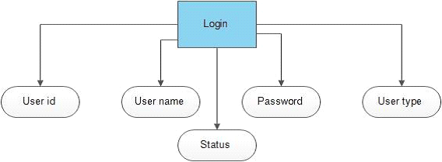

**User Detail:**

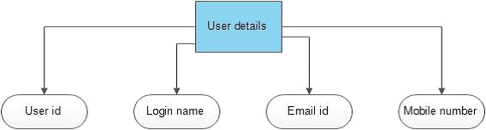

**Product Detail:**

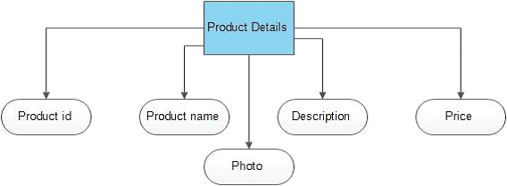

**Product Order:**



**Complete Diagram:**

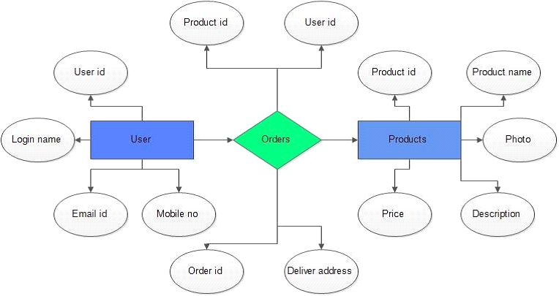

**Code:**

**Index code:**

<!DOCTYPE html>

<html lang="en">

<head>

    <meta charset="UTF-8">

    <meta http-equiv="X-UA-Compatible" content="IE=edge">

    <meta name="viewport" content="width=device-width, initial-scale=1.0">

    <title>ABCSTORE | ECOM WEBSITE</title>

    <link rel="stylesheet" href="style.css">

    <link href="https://fonts.googleapis.com/css2?family=Luxurious+Roman&family=Poppins:ital,wght@0,300;0,400;0,500;0,600;0,700;1,600&display=swap" >

    <link rel="stylesheet" href="https://stackpath.bootstrapcdn.com/font-awesome/4.7.0/css/font-awesome.min.css">

</head>

<body>

<div class="header">

<div class="container">

    <div class="navbar">

        <div class="logo">

            <a href="index.html"><img src="images/cart1.jpg" width="125px"></a>

        </div>

        <nav>

            <ul id="MenuItems">

                <li><a href="index.html">Home</a></li>

                <li><a href="products.html">Products</a></li>

                <li><a href="">About</a></li>

                <li><a href="">Contact</a></li>

                <li><a href="account.html">Account</a></li>

            </ul>

        </nav>

        <a href="cart.html">

        <img src="images/cart.jpg" width="30px" height="30px"></a>

    </div>

    <div class="row">

        <div class="col-2">

            <h1>Give You Workout <br> A New Style!</h1>

            <p>Success isn't always about greatness. It's about consistent. Consistent<br> hard work gains success. Greatness will come.</p>

            <a href="products.html"class="btn">Explore Now &#9755;</a>

        </div>

        <div class="col-2">

            <img src="images/pic2.png" >

        </div>

    </div>

</div>

</div>

<!----------featured categories-------->

<div class="categories">

    <div class="small-container">

        <div class="row">

            <div class="col-3">

                <img src="images/cat1.jpg">

            </div>

            <div class="col-3">

                <img src="images/cat2.jpg" >

            </div>

            <div class="col-3">

                <img src="images/cat3.jpg" >

            </div>

         </div>

    </div>

</div>

<!----------featured products-------->

    <div class="small-container">

        <h2 class="title">Featured Products</h2>

        <div class="row">

            <div class="col-4">

                <a href="product-details.html"><img src="images/p1.jpg"></a>

                <h4>Sweatshirt</h4>

                <div class="rating">

                    <i class="fa fa-star"></i>

                    <i class="fa fa-star"></i>

                    <i class="fa fa-star"></i>

                    <i class="fa fa-star"></i>

                    <i class="fa fa-star-o"></i>

                </div>

                <p>499.00</p>

            </div>

            <div class="col-4">

                <img src="images/p2.jpg">

                <h4>Track Pant</h4>

                <div class="rating">

                    <i class="fa fa-star"></i>

                    <i class="fa fa-star"></i>

                    <i class="fa fa-star"></i>

                    <i class="fa fa-star-half-o"></i>

                    <i class="fa fa-star-o"></i>

                </div>

                <p>499.00</p>

            </div>

            <div class="col-4">

                <img src="images/p3.jpg">

                <h4>Shoes</h4>

                <div class="rating">

                    <i class="fa fa-star"></i>

                    <i class="fa fa-star"></i>

                    <i class="fa fa-star"></i>

                    <i class="fa fa-star-o"></i>

                    <i class="fa fa-star-o"></i>

                </div>

                <p>499.00</p>

            </div>

            <div class="col-4">

                <img src="images/p4.png">

                <h4>Smart Watch</h4>

                <div class="rating">

                    <i class="fa fa-star"></i>

                    <i class="fa fa-star"></i>

                    <i class="fa fa-star"></i>

                    <i class="fa fa-star-half-o"></i>

                    <i class="fa fa-star-o"></i>

                </div>

                <p>499.00</p>

            </div>

        </div>

        <h2 class="title">Latest Products</h2>

        <div class="row">

            <div class="col-4">

                <img src="images/p5.jpg">

                <h4>Shoes</h4>

                <div class="rating">

                    <i class="fa fa-star"></i>

                    <i class="fa fa-star"></i>

                    <i class="fa fa-star"></i>

                    <i class="fa fa-star"></i>

                    <i class="fa fa-star-o"></i>

                </div>

                <p>499.00</p>

            </div>

            <div class="col-4">

                <img src="images/p6.jpg">

                <h4>Watch</h4>

                <div class="rating">

                    <i class="fa fa-star"></i>

                    <i class="fa fa-star"></i>

                    <i class="fa fa-star"></i>

                    <i class="fa fa-star-half-o"></i>

                    <i class="fa fa-star-o"></i>

                </div>

                <p>499.00</p>

            </div>

            <div class="col-4">

                <img src="images/p7.jpg">

                <h4><T-shirt></T-shirt></h4>

                <div class="rating">

                    <i class="fa fa-star"></i>

                    <i class="fa fa-star"></i>

                    <i class="fa fa-star"></i>

                    <i class="fa fa-star"></i>

                    <i class="fa fa-star"></i>

                </div>

                <p>499.00</p>

            </div>

            <div class="col-4">

                <img src="images/p8.jpg">

                <h4>Casual Shoe</h4>

                <div class="rating">

                    <i class="fa fa-star"></i>

                    <i class="fa fa-star"></i>

                    <i class="fa fa-star"></i>

                    <i class="fa fa-star-half-o"></i>

                    <i class="fa fa-star-o"></i>

                </div>

                <p>499.00</p>

            </div>

            <div class="col-4">

                <img src="images/p9.webp">

                <h4>Crocs</h4>

                <div class="rating">

                    <i class="fa fa-star"></i>

                    <i class="fa fa-star"></i>

                    <i class="fa fa-star"></i>

                    <i class="fa fa-star"></i>

                    <i class="fa fa-star-o"></i>

                </div>

                <p>499.00</p>

            </div>

            <div class="col-4">

                <img src="images/p10.jpg">

                <h4>Socks</h4>

                <div class="rating">

                    <i class="fa fa-star"></i>

                    <i class="fa fa-star"></i>

                    <i class="fa fa-star"></i>

                    <i class="fa fa-star"></i>

                    <i class="fa fa-star-o"></i>

                </div>

                <p>499.00</p>

            </div>

            <div class="col-4">

                <img src="images/p1.jpg">

                <h4>Sweatshirt</h4>

                <div class="rating">

                    <i class="fa fa-star"></i>

                    <i class="fa fa-star"></i>

                    <i class="fa fa-star"></i>

                    <i class="fa fa-star"></i>

                    <i class="fa fa-star-o"></i>

                </div>

                <p>499.00</p>

            </div>

            <div class="col-4">

                <img src="images/p1.jpg">

                <h4>Sweatshirt</h4>

                <div class="rating">

                    <i class="fa fa-star"></i>

                    <i class="fa fa-star"></i>

                    <i class="fa fa-star"></i>

                    <i class="fa fa-star"></i>

                    <i class="fa fa-star-o"></i>

                </div>

                <p>499.00</p>

            </div>

        </div>

    </div>

    <!----offer------->

    <div class="offer">

        <div class="small-container">

            <div class="row">

                <div class="col-2">

                    <img src="images/offer2.jpg" class="offer-img">

                </div>

                <div class="col-2">

                    <p>Exclusively Available on ABC Store</p>

                    <h1>Smart Brand 4</h1>

                    <small>The MI Smart Brand 4 features a 39.9%larger(than Brand 3)AMOLED color full-touch display with adjustable brightness,so everything bris clear as can be.

                    </small>

                    <a href=""class="btn"> Buy Now &#8594;</a>

                </div>

            </div>

        </div>

    </div>

<!------testimonial-------->

<div class="testimonial">

    <div class="small-container">

        <div class="row">

            <div class="col-3">

                <i class="fa fa-quote-left "></i>

                <p>Lorem Ipsum is simple dummy text of the printing and typesetting industry. Lorem Ipsum has been the industry's standard dummy text ever</p>

                <div class="rating">

                    <i class="fa fa-star"></i>

                    <i class="fa fa-star"></i>

                    <i class="fa fa-star"></i>

                    <i class="fa fa-star"></i>

                    <i class="fa fa-star-o"></i>

                </div>

                <img src="images/user1.jpg" >

                <h3>sean parker</h3>

            </div>

            <div class="col-3">

                <i class="fa fa-quote-left "></i>

                <p>Lorem Ipsum is simple dummy text of the printing and typesetting industry. Lorem Ipsum has been the industry's standard dummy text ever</p>

                <div class="rating">

                    <i class="fa fa-star"></i>

                    <i class="fa fa-star"></i>

                    <i class="fa fa-star"></i>

                    <i class="fa fa-star-half-o"></i>

                    <i class="fa fa-star-o"></i>

                </div>

                <img src="images/user2.jpg" >

                <h3>George</h3>

            </div>

            <div class="col-3">

                <i class="fa fa-quote-left "></i>

                <p>Lorem Ipsum is simple dummy text of the printing and typesetting industry. Lorem Ipsum has been the industry's standard dummy text ever</p>

                <div class="rating">

                    <i class="fa fa-star"></i>

                    <i class="fa fa-star"></i>

                    <i class="fa fa-star"></i>

                    <i class="fa fa-star"></i>

                    <i class="fa fa-star"></i>

                </div>

                <img src="images/user3.jpg" >

                <h3>Mr Adam</h3>

            </div>

        </div>

    </div>

</div>

<!------brands-------->

<div class="brands">

    <div class="small-container">

        <div class="row">

            <div class="col-5">

                <img src="images/splogo1.png" >

            </div>

            <div class="col-5">

                <img src="images/splogo2.png" >

            </div>

            <div class="col-5">

                <img src="images/splogo3.png" >

            </div>

            <div class="col-5">

                <img src="images/splogo4.jpg" >

            </div>

            <div class="col-5">

                <img src="images/splogo5.webp" >

            </div>

        </div>

    </div>

</div>

<!-------footer---->

<div class="footer">

    <div class="container">

        <div class="row">

            <div class="footer-col-1">

                <h3>Download our App</h3>

                <p>Downlaod App for Android and ios mobile phone.</p>

                <div class="app-logo">

                    <img src="images/playlogo.png" >

                    <img src="images/applogo.jpg" >

                </div>

            </div>

            <div class="footer-col-2">

                <img src="images/cart1.jpg">

                <p>Downlaod App for Android and ios mobile phone.</p>

            </div>

            <div class="footer-col-3">

                <h3>Useful Links</h3>

                <ul>

                    <li>Coupons</li>

                    <li>Blog Post</li>

                    <li>Return Policy</li>

                    <li>Join affiliate</li>

                </ul>

            </div>

            <div class="footer-col-4">

                <h3>Follow us</h3>

                <ul>

                    <li>Facebook</li>

                    <li>Twitter</li>

                    <li>Instagram</li>

                    <li>Youtube</li>

                </ul>

            </div>

        </div>

        <hr>

        <p class="copyright">Copyright 2020</p>

    </div>

</div>

</body>

</html>

SCREENSHOT:

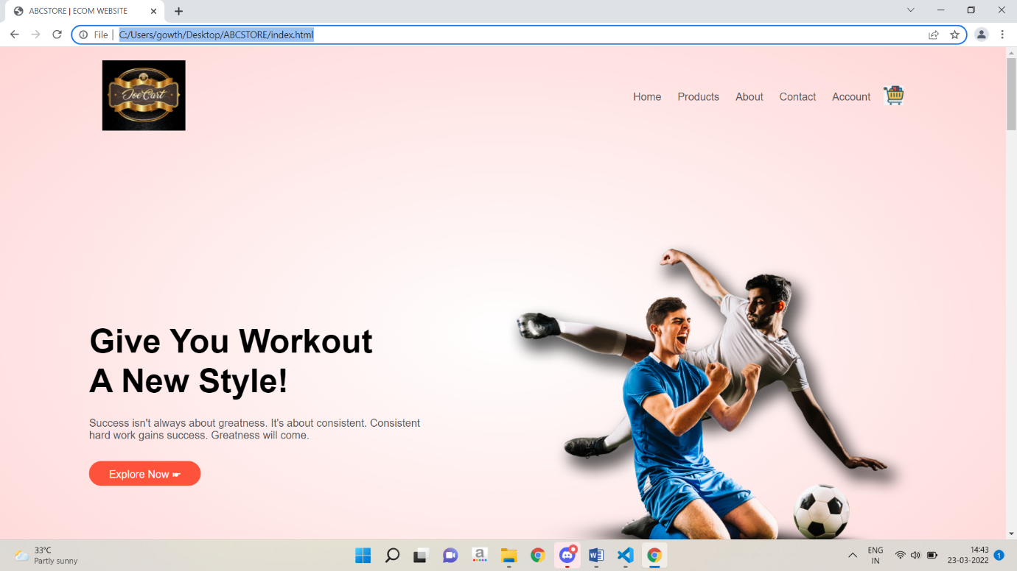

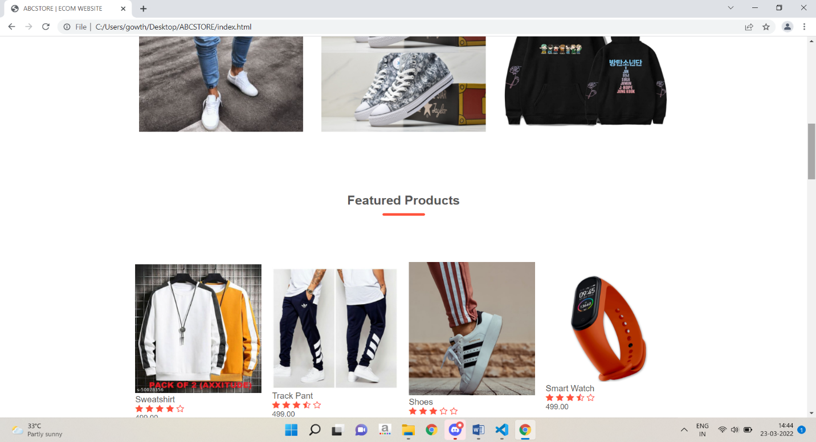

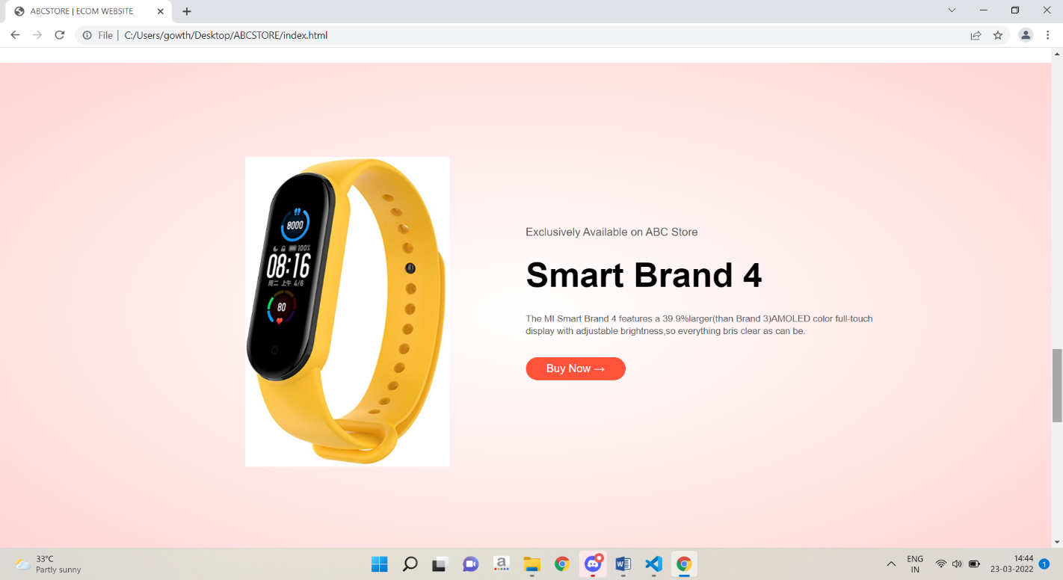

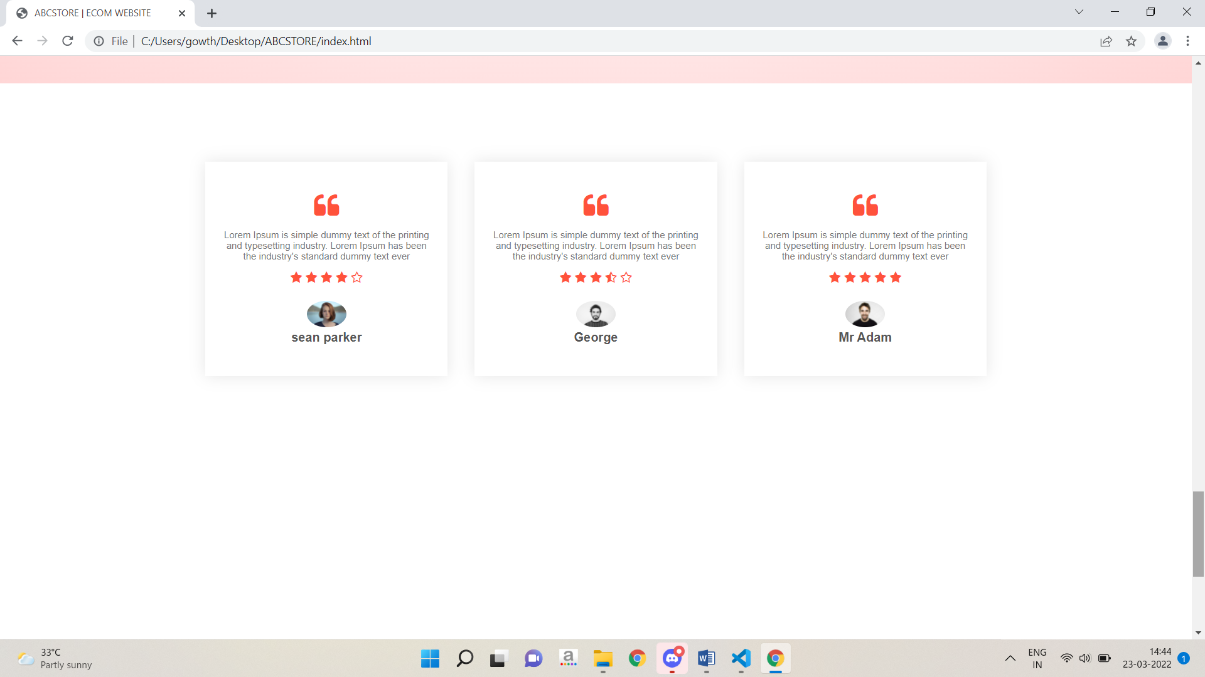

**Product page code:**

<!DOCTYPE html>

<html lang="en">

<head>

    <meta charset="UTF-8">

    <meta http-equiv="X-UA-Compatible" content="IE=edge">

    <meta name="viewport" content="width=device-width, initial-scale=1.0">

    <title>All Products- ABCSTORE </title>

    <link rel="stylesheet" href="style.css">

    <link href="https://fonts.googleapis.com/css2?family=Luxurious+Roman&family=Poppins:ital,wght@0,300;0,400;0,500;0,600;0,700;1,600&display=swap" >

    <link rel="stylesheet" href="https://stackpath.bootstrapcdn.com/font-awesome/4.7.0/css/font-awesome.min.css">

</head>

<body>

<div class="container">

    <div class="navbar">

        <div class="logo">

            <a href="index.html"><img src="images/cart1.jpg" width="125px"></a>

        </div>

        <nav>

            <ul id="MenuItems">

                <li><a href="index.html">Home</a></li>

                <li><a href="products.html">Products</a></li>

                <li><a href="">About</a></li>

                <li><a href="">Contact</a></li>

                <li><a href="account.html">Account</a></li>

            </ul>

        </nav>

        <a href="cart.html">

        <img src="images/cart.jpg" width="30px" height="30px"></a>

    </div>

</div>

    <div class="small-container">

        <div class="row row-2">

            <h2>All Products</h2>

            <select>

                <option>Short by</option>

                <option>Short by price</option>

                <option>Short by rating</option>

                <option>Short by popularity</option>

                <option>Short by Sale</option>

            </select>

        </div>

        <div class="row">

            <div class="col-4">

                <a href="product-details.html"><img src="images/p1.jpg"> </a>

                <h4>Sweatshirt</h4>

                <div class="rating">

                    <i class="fa fa-star"></i>

                    <i class="fa fa-star"></i>

                    <i class="fa fa-star"></i>

                    <i class="fa fa-star"></i>

                    <i class="fa fa-star-o"></i>

                </div>

                <p>499.00</p>

            </div>

            <div class="col-4">

                <img src="images/p2.jpg">

                <h4>Track Pant</h4>

                <div class="rating">

                    <i class="fa fa-star"></i>

                    <i class="fa fa-star"></i>

                    <i class="fa fa-star"></i>

                    <i class="fa fa-star-half-o"></i>

                    <i class="fa fa-star-o"></i>

                </div>

                <p>499.00</p>

            </div>

            <div class="col-4">

                <img src="images/p3.jpg">

                <h4>Shoes</h4>

                <div class="rating">

                    <i class="fa fa-star"></i>

                    <i class="fa fa-star"></i>

                    <i class="fa fa-star"></i>

                    <i class="fa fa-star-o"></i>

                    <i class="fa fa-star-o"></i>

                </div>

                <p>499.00</p>

            </div>

            <div class="col-4">

                <img src="images/p4.png">

                <h4>Smart Watch</h4>

                <div class="rating">

                    <i class="fa fa-star"></i>

                    <i class="fa fa-star"></i>

                    <i class="fa fa-star"></i>

                    <i class="fa fa-star-half-o"></i>

                    <i class="fa fa-star-o"></i>

                </div>

                <p>499.00</p>

            </div>

        </div>

        <div class="row">

            <div class="col-4">

                <img src="images/p5.jpg">

                <h4>Shoes</h4>

                <div class="rating">

                    <i class="fa fa-star"></i>

                    <i class="fa fa-star"></i>

                    <i class="fa fa-star"></i>

                    <i class="fa fa-star"></i>

                    <i class="fa fa-star-o"></i>

                </div>

                <p>499.00</p>

            </div>

            <div class="col-4">

                <img src="images/p6.jpg">

                <h4>Watch</h4>

                <div class="rating">

                    <i class="fa fa-star"></i>

                    <i class="fa fa-star"></i>

                    <i class="fa fa-star"></i>

                    <i class="fa fa-star-half-o"></i>

                    <i class="fa fa-star-o"></i>

                </div>

                <p>499.00</p>

            </div>

            <div class="col-4">

                <img src="images/p7.jpg">

                <h4><T-shirt></T-shirt></h4>

                <div class="rating">

                    <i class="fa fa-star"></i>

                    <i class="fa fa-star"></i>

                    <i class="fa fa-star"></i>

                    <i class="fa fa-star"></i>

                    <i class="fa fa-star"></i>

                </div>

                <p>499.00</p>

            </div>

            <div class="col-4">

                <img src="images/p8.jpg">

                <h4>Casual Shoe</h4>

                <div class="rating">

                    <i class="fa fa-star"></i>

                    <i class="fa fa-star"></i>

                    <i class="fa fa-star"></i>

                    <i class="fa fa-star-half-o"></i>

                    <i class="fa fa-star-o"></i>

                </div>

                <p>499.00</p>

            </div>

            <div class="col-4">

                <img src="images/p9.webp">

                <h4>Crocs</h4>

                <div class="rating">

                    <i class="fa fa-star"></i>

                    <i class="fa fa-star"></i>

                    <i class="fa fa-star"></i>

                    <i class="fa fa-star"></i>

                    <i class="fa fa-star-o"></i>

                </div>

                <p>499.00</p>

            </div>

            <div class="col-4">

                <img src="images/p10.jpg">

                <h4>Socks</h4>

                <div class="rating">

                    <i class="fa fa-star"></i>

                    <i class="fa fa-star"></i>

                    <i class="fa fa-star"></i>

                    <i class="fa fa-star"></i>

                    <i class="fa fa-star-o"></i>

                </div>

                <p>499.00</p>

            </div>

            <div class="col-4">

                <img src="images/p1.jpg">

                <h4>Sweatshirt</h4>

                <div class="rating">

                    <i class="fa fa-star"></i>

                    <i class="fa fa-star"></i>

                    <i class="fa fa-star"></i>

                    <i class="fa fa-star"></i>

                    <i class="fa fa-star-o"></i>

                </div>

                <p>499.00</p>

            </div>

            <div class="col-4">

                <img src="images/p1.jpg">

                <h4>Sweatshirt</h4>

                <div class="rating">

                    <i class="fa fa-star"></i>

                    <i class="fa fa-star"></i>

                    <i class="fa fa-star"></i>

                    <i class="fa fa-star"></i>

                    <i class="fa fa-star-o"></i>

                </div>

                <p>499.00</p>

            </div>

        </div>

        <div class="page-btn">

            <span>1</span>

            <span>2</span>

            <span>3</span>

            <span>4</span>

            <a href="index.html">

            <span>Back</span>

        </a>

            <span> &#8594;</span>

        </div>

    </div>

<!-------footer---->

<div class="footer">

    <div class="container">

        <div class="row">

            <div class="footer-col-1">

                <h3>Download our App</h3>

                <p>Downlaod App for Android and ios mobile phone.</p>

                <div class="app-logo">

                    <img src="images/playlogo.png" >

                    <img src="images/applogo.jpg" >

                </div>

            </div>

            <div class="footer-col-2">

                <img src="images/cart1.jpg">

                <p>Downlaod App for Android and ios mobile phone.</p>

            </div>

            <div class="footer-col-3">

                <h3>Useful Links</h3>

                <ul>

                    <li>Coupons</li>

                    <li>Blog Post</li>

                    <li>Return Policy</li>

                    <li>Join affiliate</li>

                </ul>

            </div>

            <div class="footer-col-4">

                <h3>Follow us</h3>

                <ul>

                    <li>Facebook</li>

                    <li>Twitter</li>

                    <li>Instagram</li>

                    <li>Youtube</li>

                </ul>

            </div>

        </div>

        <hr>

        <p class="copyright">Copyright 2020</p>

    </div>

</div>

</body>

</html>

**SCREENSHOT:**

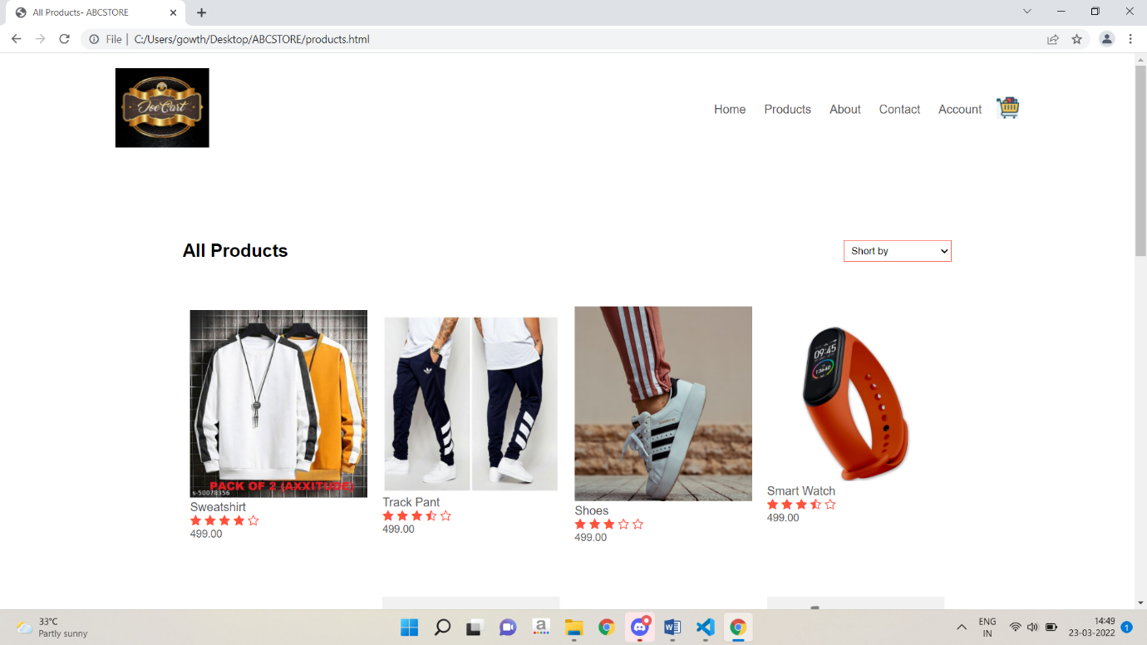

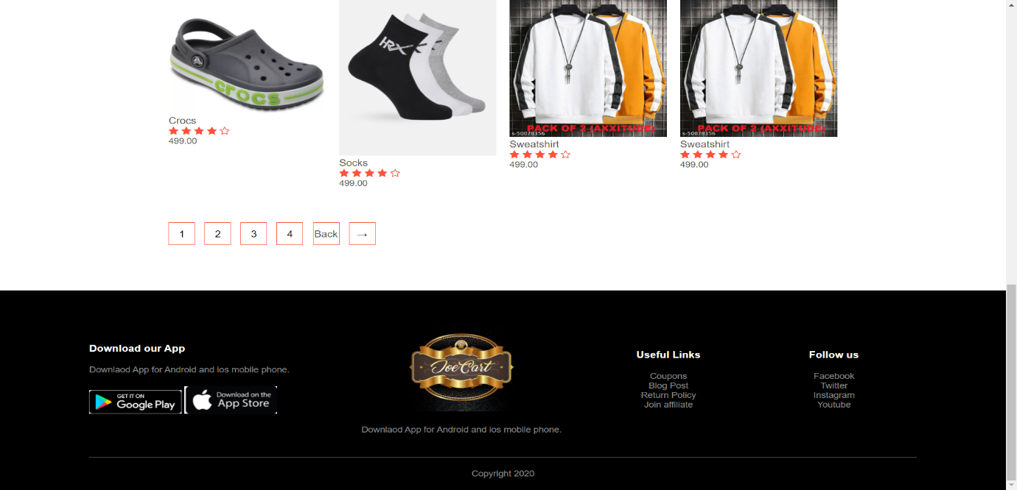

**PRODUCT DETAIL PAGE CODE:**

<!DOCTYPE html>

<html lang="en">

<head>

    <meta charset="UTF-8">

    <meta http-equiv="X-UA-Compatible" content="IE=edge">

    <meta name="viewport" content="width=device-width, initial-scale=1.0">

    <title>All Products- ABCSTORE </title>

    <link rel="stylesheet" href="style.css">

    <link href="https://fonts.googleapis.com/css2?family=Luxurious+Roman&family=Poppins:ital,wght@0,300;0,400;0,500;0,600;0,700;1,600&display=swap" >

    <link rel="stylesheet" href="https://stackpath.bootstrapcdn.com/font-awesome/4.7.0/css/font-awesome.min.css">

</head>

<body>

<div class="container">

    <div class="navbar">

        <div class="logo">

            <a href="index.html"><img src="images/cart1.jpg" width="125px"></a>

        </div>

        <nav>

            <ul id="MenuItems">

                <li><a href="index.html">Home</a></li>

                <li><a href="products.html">Products</a></li>

                <li><a href="">About</a></li>

                <li><a href="">Contact</a></li>

                <li><a href="account.html">Account</a></li>

            </ul>

        </nav>

        <a href="cart.html">

        <img src="images/cart.jpg" width="30px" height="30px"></a>

    </div>

</div>

<!----------------------single product details--------------------------->

<div class="small-container single-product">

    <div class="row">

        <div class="col-2">

            <img src="images/pd4.jpg" width="100%" id="ProductImg">

            <div class="small-img-row">

                <div class="small-img-col">

                    <img src="images/pd2.jpg" width="100%" class="small-img">

                </div>

                <div class="small-img-col">

                    <img src="images/pd3.jpg" width="100%" class="small-img">

                </div>

                <div class="small-img-col">

                    <img src="images/pd1.jpg" width="100%" class="small-img">

                </div>

                <div class="small-img-col">

                    <img src="images/pd5.jpg" width="100%" class="small-img">

                </div>

            </div>

        </div>

        <div class="col-2">

            <p>Home / Sweatshirt</p>

            <h1>Two printed Sweatshirt</h1>

            <h4>499.00</h4>

            <select >

                <option>Select Size</option>

                <option>XXL</option>

                <option>XL</option>

                <option>Large</option>

                <option>Small</option>

                <option>Medium</option>

                </select>

                <input type="number" value="1">

                <a href="cart.html" class="btn">Add to cart</a>

                <h3>Product Details <i class="fa fa-indent"></i></h3>

                <br>

                <p>Sweatshirts are designed to induce and absorb sweat, so they keep you warm while cooling you down slowly. Unless it's scorching out there though, a sweatshirt is pretty much good to go! With the right pair of shorts or a cute little skirt, you might even make a fashion statement as you dress up a sweatshirt.</p>

        </div>

    </div>

</div>

<!----------Title------------>

<div class="small-container">

    <div class="row row-2">

        <h2>Related Products</h2>

        <p>View More</p>

    </div>

</div>

<!---------Products------------>

<div class="small-container">

        <div class="row">

            <div class="col-4">

                <img src="images/p9.webp">

                <h4>Crocs</h4>

                <div class="rating">

                    <i class="fa fa-star"></i>

                    <i class="fa fa-star"></i>

                    <i class="fa fa-star"></i>

                    <i class="fa fa-star"></i>

                    <i class="fa fa-star-o"></i>

                </div>

                <p>499.00</p>

            </div>

            <div class="col-4">

                <img src="images/p10.jpg">

                <h4>Socks</h4>

                <div class="rating">

                    <i class="fa fa-star"></i>

                    <i class="fa fa-star"></i>

                    <i class="fa fa-star"></i>

                    <i class="fa fa-star"></i>

                    <i class="fa fa-star-o"></i>

                </div>

                <p>499.00</p>

            </div>

            <div class="col-4">

                <img src="images/p1.jpg">

                <h4>Sweatshirt</h4>

                <div class="rating">

                    <i class="fa fa-star"></i>

                    <i class="fa fa-star"></i>

                    <i class="fa fa-star"></i>

                    <i class="fa fa-star"></i>

                    <i class="fa fa-star-o"></i>

                </div>

                <p>499.00</p>

            </div>

            <div class="col-4">

                <img src="images/p1.jpg">

                <h4>Sweatshirt</h4>

                <div class="rating">

                    <i class="fa fa-star"></i>

                    <i class="fa fa-star"></i>

                    <i class="fa fa-star"></i>

                    <i class="fa fa-star"></i>

                    <i class="fa fa-star-o"></i>

                </div>

                <p>499.00</p>

            </div>

        </div>

    </div>

<!-------footer---->

<div class="footer">

    <div class="container">

        <div class="row">

            <div class="footer-col-1">

                <h3>Download our App</h3>

                <p>Downlaod App for Android and ios mobile phone.</p>

                <div class="app-logo">

                    <img src="images/playlogo.png" >

                    <img src="images/applogo.jpg" >

                </div>

            </div>

            <div class="footer-col-2">

                <img src="images/cart1.jpg">

                <p>Downlaod App for Android and ios mobile phone.</p>

            </div>

            <div class="footer-col-3">

                <h3>Useful Links</h3>

                <ul>

                    <li>Coupons</li>

                    <li>Blog Post</li>

                    <li>Return Policy</li>

                    <li>Join affiliate</li>

                </ul>

            </div>

            <div class="footer-col-4">

                <h3>Follow us</h3>

                <ul>

                    <li>Facebook</li>

                    <li>Twitter</li>

                    <li>Instagram</li>

                    <li>Youtube</li>

                </ul>

            </div>

        </div>

        <hr>

        <p class="copyright">Copyright 2020</p>

    </div>

</div>

<!---------------js for product gallary--------->

<script>

    var ProductImg = document.getElementById("ProductImg");

    var SmallImg = document.getElementsByClassName("small-img");

    SmallImg[0].onclick = function()

    {

        ProductImg.src = SmallImg[0].src;

    }

    SmallImg[1].onclick = function()

    {

        ProductImg.src = SmallImg[1].src;

    }

    SmallImg[2].onclick = function()

    {

        ProductImg.src = SmallImg[2].src;

    }

    SmallImg[3].onclick = function()

    {

        ProductImg.src = SmallImg[3].src;

    }

</script>

</body>

</html>

CART PAGE CODE:

<!DOCTYPE html>

<html lang="en">

<head>

    <meta charset="UTF-8">

    <meta http-equiv="X-UA-Compatible" content="IE=edge">

    <meta name="viewport" content="width=device-width, initial-scale=1.0">

    <title>All Products- ABCSTORE </title>

    <link rel="stylesheet" href="style.css">

    <link href="https://fonts.googleapis.com/css2?family=Luxurious+Roman&family=Poppins:ital,wght@0,300;0,400;0,500;0,600;0,700;1,600&display=swap" >

    <link rel="stylesheet" href="https://stackpath.bootstrapcdn.com/font-awesome/4.7.0/css/font-awesome.min.css">

</head>

<body>

<div class="container">

    <div class="navbar">

        <div class="logo">

            <a href="index.html"><img src="images/cart1.jpg" width="125px"></a>

        </div>

        <nav>

            <ul id="MenuItems">

                <li><a href="index.html">Home</a></li>

                <li><a href="products.html">Products</a></li>

                <li><a href="">About</a></li>

                <li><a href="">Contact</a></li>

                <li><a href="account.html">Account</a></li>

            </ul>

        </nav>

        <a href="cart.html">

        <img src="images/cart.jpg" width="30px" height="30px"></a>

    </div>

</div>

 <!----------------cart items details------->

 <div class="small-container cart-page">

    <table>

        <tr>

            <th>Product</th>

            <th>Quantity</th>

            <th>Subtotal</th>

        </tr>

        <tr>

            <td>

                <div class="cart-info">

                    <img src="images/p1.jpg">

                    <div>

                        <p>Printed Sweatshirt</p>

                        <small>Price: 350.00</small>

                        <br>

                        <a href="">Remove</a>

                    </div>

                </div>

            </td>

            <td><input type="number" value="1"></td>

            <td>350.00</td>

        </tr>

        <tr>

            <td>

                <div class="cart-info">

                    <img src="images/p3.jpg">

                    <div>

                        <p>Printed Shoes</p>

                        <small>Price: 400.00</small>

                        <br>

                        <a href="">Remove</a>

                    </div>

                </div>

            </td>

            <td><input type="number" value="1"></td>

            <td>400.00</td>

        </tr>

        <tr>

            <td>

                <div class="cart-info">

                    <img src="images/p2.jpg">

                    <div>

                        <p>Printed Pants</p>

                        <small>Price: 500.00</small>

                        <br>

                        <a href="">Remove</a>

                    </div>

                </div>

            </td>

            <td><input type="number" value="1"></td>

            <td>500.00</td>

        </tr>

    </table>

    <div class="total-price">

        <table>

            <tr>

                <td>Subtotal</td>

                <td>Rs: 1250</td>

            </tr>

            <tr>

                <td>Tax</td>

                <td>Rs: 100</td>

            </tr>

            <tr>

                <td>Total</td>

                <td>Rs: 1350</td>

            </tr>

        </table>

    </div>

    <div class="col-5">

        <a href="pay.html" class="btn">proced to pay</a>

    </div>

 </div>

 <!-------footer---->

<div class="footer">

    <div class="container">

        <div class="row">

            <div class="footer-col-1">

                <h3>Download our App</h3>

                <p>Downlaod App for Android and ios mobile phone.</p>

                <div class="app-logo">

                    <img src="images/playlogo.png" >

                    <img src="images/applogo.jpg" >

                </div>

            </div>

            <div class="footer-col-2">

                <img src="images/cart1.jpg">

                <p>Downlaod App for Android and ios mobile phone.</p>

            </div>

            <div class="footer-col-3">

                <h3>Useful Links</h3>

                <ul>

                    <li>Coupons</li>

                    <li>Blog Post</li>

                    <li>Return Policy</li>

                    <li>Join affiliate</li>

                </ul>

            </div>

            <div class="footer-col-4">

                <h3>Follow us</h3>

                <ul>

                    <li>Facebook</li>

                    <li>Twitter</li>

                    <li>Instagram</li>

                    <li>Youtube</li>

                </ul>

            </div>

        </div>

        <hr>

        <p class="copyright">Copyright 2020</p>

    </div>

</div>

</body>

</html>

**SCREENSHOTS:**

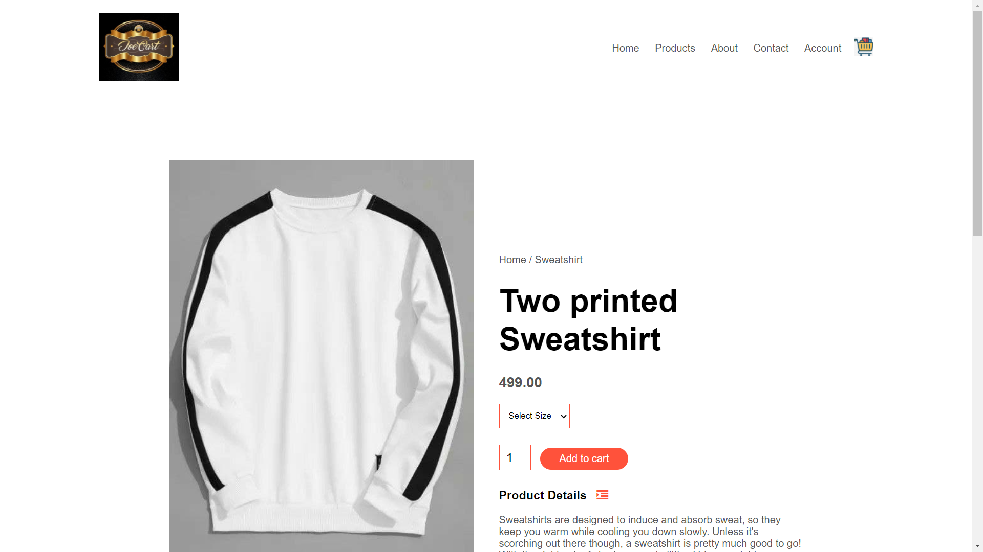

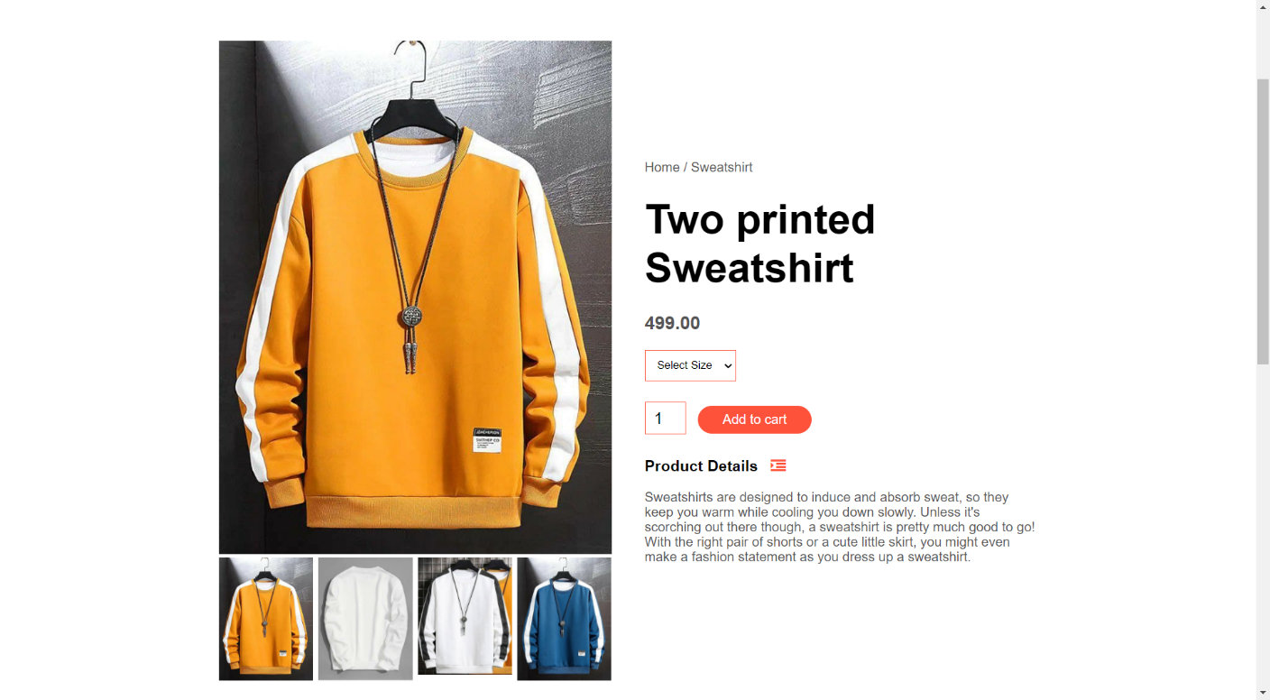

**LOGIN PAGE CODE:**

<!DOCTYPE html>

<html lang="en">

<head>

    <meta charset="UTF-8">

    <meta http-equiv="X-UA-Compatible" content="IE=edge">

    <meta name="viewport" content="width=device-width, initial-scale=1.0">

    <title>All Products- ABCSTORE </title>

    <link rel="stylesheet" href="style.css">

    <link href="https://fonts.googleapis.com/css2?family=Luxurious+Roman&family=Poppins:ital,wght@0,300;0,400;0,500;0,600;0,700;1,600&display=swap" >

    <link rel="stylesheet" href="https://stackpath.bootstrapcdn.com/font-awesome/4.7.0/css/font-awesome.min.css">

</head>

<body>

<div class="container">

    <div class="navbar">

        <div class="logo">

            <a href="index.html"><img src="images/cart1.jpg" width="125px"></a>

        </div>

        <nav>

            <ul id="MenuItems">

                <li><a href="index.html">Home</a></li>

                <li><a href="products.html">Products</a></li>

                <li><a href="">About</a></li>

                <li><a href="">Contact</a></li>

                <li><a href="account.html">Account</a></li>

            </ul>

        </nav>

        <a href="cart.html">

        <img src="images/cart.jpg" width="30px" height="30px">

    </a>

    </div>

</div>

<!------ account-page ----------->

<div class="account-page">

    <div class="container">

        <div class="row">

            <div class="col-2">

                <img src="images/pic2.png" width="100%">

            </div>

            <div class="col-2">

               <div class="form-container">

                   <div class="form-btn">

                       <span onclick="login()">Login</span>

                       <span onclick ="register()">Register</span>

                       <hr id="Indicator">

                   </div>

                   <form id="LoginForm">

                       <input type="text" placeholder="Username">

                       <input type="Password" placeholder="Password">

                       <button type="submit" class="btn">Login</button>

                       <a href="">Forgot Password</a>

                   </form>

                   <form id="RegForm">

                    <input type="text" placeholder="Username">

                    <input type="email" placeholder="Email">

                    <input type="Password" placeholder="Password">

                    <button type="submit" class="btn">Register</button>

                    <a href="">Forgot Password</a>

                </form>

               </div>

            </div>

        </div>

    </div>

</div>

<!-------footer---->

<div class="footer">

    <div class="container">

        <div class="row">

            <div class="footer-col-1">

                <h3>Download our App</h3>

                <p>Downlaod App for Android and ios mobile phone.</p>

                <div class="app-logo">

                    <img src="images/playlogo.png" >

                    <img src="images/applogo.jpg" >

                </div>

            </div>

            <div class="footer-col-2">

                <img src="images/cart1.jpg">

                <p>Downlaod App for Android and ios mobile phone.</p>

            </div>

            <div class="footer-col-3">

                <h3>Useful Links</h3>

                <ul>

                    <li>Coupons</li>

                    <li>Blog Post</li>

                    <li>Return Policy</li>

                    <li>Join affiliate</li>

                </ul>

            </div>

            <div class="footer-col-4">

                <h3>Follow us</h3>

                <ul>

                    <li>Facebook</li>

                    <li>Twitter</li>

                    <li>Instagram</li>

                    <li>Youtube</li>

                </ul>

            </div>

        </div>

        <hr>

        <p class="copyright">Copyright 2020</p>

    </div>

</div>

<!-----------js for toogle menu----->

<script>

    var MenuItems = document.getElementById("MenuItems");

    MenuItems.style.maxHeight = "0px";

    function menutoggle(){

        if(MenuItems.style.maxHeight=="0px"){

            MenuItems.style.maxHeight="200px";

        }

        else

        {

            MenuItems.style.maxHeight="0px";

        }

    }

</script>

<!-----------js for toggle form------>

<script>

    var LoginForm = document.getElementById("LoginForm");

    var RegForm = document.getElementById("RegForm");

    var Indicator = document.getElementById("Indicator");

function register(){

        RegForm.style.transform = "translateX(0px)";

        LoginForm.style.transform = "translateX(0px)";

        Indicator.style.transform = "translateX(100px)";

}

    function login(){

        RegForm.style.transform = "translateX(300px)";

        LoginForm.style.transform = "translateX(300px)";

        Indicator.style.transform = "translateX(0px)";

    }

</script>

</body>

</html>

**SCREENSHOTS:**

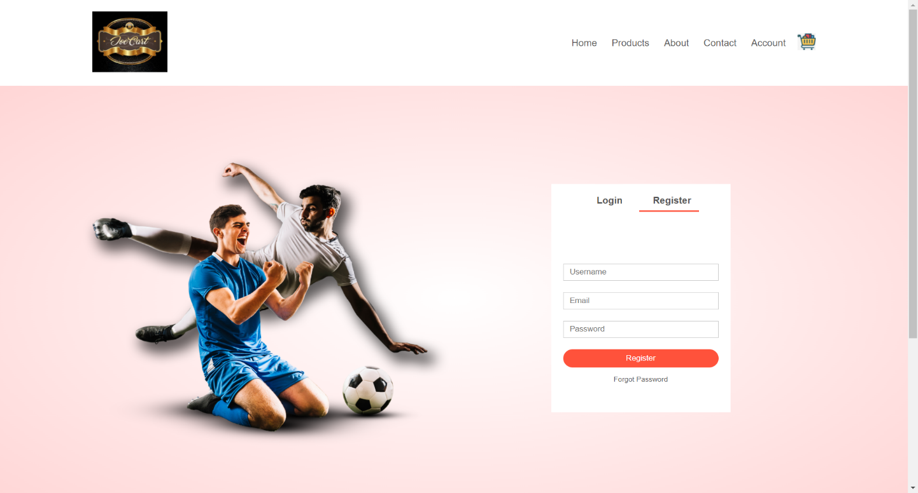

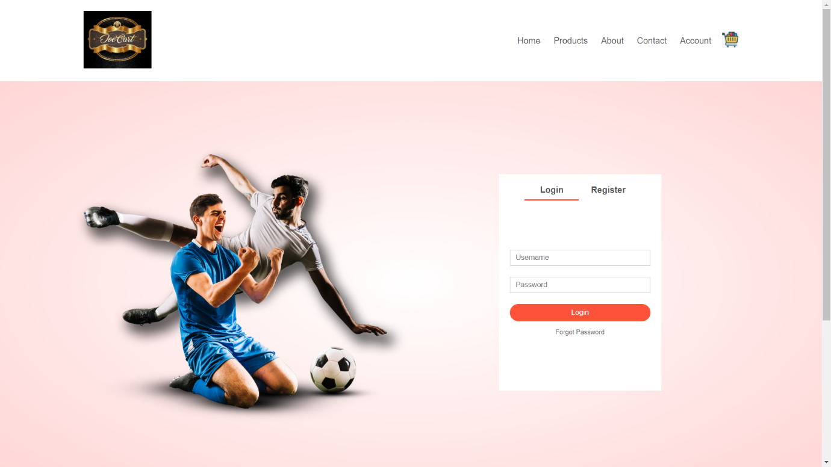

**PAYMENT PAGE CODE:**

<!DOCTYPE html>

<html lang="en">

<head>

    <meta charset="UTF-8">

    <meta http-equiv="X-UA-Compatible" content="IE=edge">

    <meta name="viewport" content="width=device-width, initial-scale=1.0">

    <title>All Products- ABCSTORE </title>

    <link rel="stylesheet" href="style.css">

    <link href="https://fonts.googleapis.com/css2?family=Luxurious+Roman&family=Poppins:ital,wght@0,300;0,400;0,500;0,600;0,700;1,600&display=swap" >

    <link rel="stylesheet" href="https://stackpath.bootstrapcdn.com/font-awesome/4.7.0/css/font-awesome.min.css">

</head>

<div class="container">

    <div class="navbar">

        <div class="logo">

            <a href="index.html"><img src="images/cart1.jpg" width="125px"></a>

        </div>

    </div>

</div>

<body-1>

<div class="container-1">

    <h1>Confirm your payment</h1>

        <div class="first-row">

            <div class="owner">

                <h2>CardHolderName</h2>

                <div class="input-field">

                    <input type="text">

                </div>

            </div>

            <div class="cvv">

                <h2>cvv</h2>

                <div class="input-field">

                    <input type="password">

                </div>

            </div>

        </div>

        <div class="second-row">

            <div class="card-number">

                <h2>Card Number</h2>

                <div class="input-field">

                    <input type="text">

                </div>

            </div>

        </div>

        <div class="third-row">

                <h2>Expire </h2>

                <div class="selection">

                    <div class="date">

                        <select name="months" id="months">

                            <option value="Jan">Jan</option>

                            <option value="Feb">Feb</option>

                            <option value="Mar">Mar</option>

                            <option value="Apr">Apr</option>

                            <option value="May">May</option>

                            <option value="Jun">Jun</option>

                            <option value="Jul">Jul</option>

                            <option value="Aug">Aug</option>

                            <option value="Sep">Sep</option>

                            <option value="Oct">Oct</option>

                            <option value="Nov">Nov</option>

                            <option value="Dec">Dec</option>

                        </select>

                        <select name="years" id="years">

                            <option value="2020">2020</option>

                            <option value="2019">2019</option>

                            <option value="2018">2018</option>

                            <option value="2017">2017</option>

                            <option value="2016">2016</option>

                            <option value="2015">2015</option>

                        </select>

                    </div>

                    <div class="cards">

                        <img src="images/pay1.png" >

                        <img src="images/pay2.png" >

                        <img src="images/pay3.png" >

                    </div>

                </div>

        </div>

        <a-1 href="">confirm</a-1>

        <a-1>

            <a href="cart.html" >Back to cart</a>

        </a-1>

</div>

</body-1>

<!-------footer---->

<div class="footer">

    <div class="container">

        <div class="row">

            <div class="footer-col-1">

                <h3>Download our App</h3>

                <p>Downlaod App for Android and ios mobile phone.</p>

                <div class="app-logo">

                    <img src="images/playlogo.png" >

                    <img src="images/applogo.jpg" >

                </div>

            </div>

            <div class="footer-col-2">

                <img src="images/cart1.jpg">

                <p>Downlaod App for Android and ios mobile phone.</p>

            </div>

            <div class="footer-col-3">

                <h3>Useful Links</h3>

                <ul>

                    <li>Coupons</li>

                    <li>Blog Post</li>

                    <li>Return Policy</li>

                    <li>Join affiliate</li>

                </ul>

            </div>

            <div class="footer-col-4">

                <h3>Follow us</h3>

                <ul>

                    <li>Facebook</li>

                    <li>Twitter</li>

                    <li>Instagram</li>

                    <li>Youtube</li>

                </ul>

            </div>

        </div>

        <hr>

        <p class="copyright">Copyright 2020</p>

    </div>

</div>

<!-----------js for toogle menu----->

<script>

    var MenuItems = document.getElementById("MenuItems");

    MenuItems.style.maxHeight = "0px";

    function menutoggle(){

        if(MenuItems.style.maxHeight=="0px"){

            MenuItems.style.maxHeight="200px";

        }

        else

        {

            MenuItems.style.maxHeight="0px";

        }

    }

</script>

</html>

**SCREENSHOTS:**

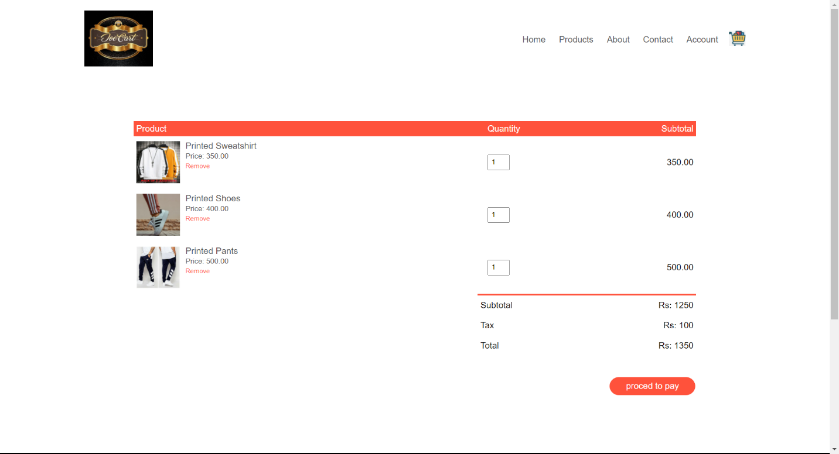

**Future Scope of Online Shopping System**

Our designed online shopping system provides a 24×7 service, that is customers can surf the website, place orders anytime they wish to. Also, the delivery system works 24×7 hours a week. Some of the features that can be modified and added to this system in the future involve its implementation by local shopkeepers, where shops will be providing an online interface to customers for shopping and placing orders. Then some delivery persons can perform their work. This will be adding on benefit for the customers as it will save their time, plus it adds on for the shopkeepers also, as people will continue to shop from local shops rather than preferring to supermarkets every time. Also, since the deliveries from these local vendors will not be as time-consuming as these days Flipkart, Amazon, etc. take but rather will be delivered the same day of an order placed. Else the shopkeeper can ask the customer that the product will be available by the next day, so if he/she still wants to place the order, it can be done. Again, return or exchange will be easy since the delivery boy can even do it as the store is nearby. Including a chat box for public benefit is also a great idea via which people can directly have a conversation with some officials regarding any type of queries. Customers get a clear understanding of any online product with detailed information present on the site. Such information may involve the product’s functionalities, specifications, and images with prices. With this, businesses hope to gain the trust of customers along with other details with all online security measures followed. Most of them involve E-wallets, online card payments, and m-banking which makes the payment procedure quite flexible. Thus, such steps taken by e-Commerce businesses present a highly customized and user-friendly experience for both the entrepreneur and the consumer

**Advantages to Sellers and Customers**

The reason for the rising scope of online shopping is the advantages that it provides to sellers and customers with innumerable benefits through online selling and purchasing.

**Benefits to Sellers:**

Through online shopping, sellers widen their reach to customers beyond their cities. They get customers from every corner of the country or even the world provided they will ship their products. Also, small businesses get benefits through online shopping by extending their sales area beyond their shop walls. With this, their small businesses could witness enormous growth with massive savings on infrastructure. Again, online stores offer savings on salaries with no minimal staff, electricity bills, and other utilities.

In addition, through online shopping, sellers need not worry about their losses during holidays, strikes, or even lockdowns as they remain functioning around the clock. Further, sellers could deal in a wide range of products by responding quickly to market demands. They may even analyse customer buying patterns, preferences, and offer them customized discounts and services. In addition, small traders and manufacturers get the seal of legitimacy by selling via online retail sites like Amazon, Flipkart, and others.

**Benefits to Customers:**

The most valuable advantage that customers witness in any online shopping purchasing is the savings of their precious time. They could easily buy any product from their home, during their travel, or from other areas at any time. So, they need not worry about store closing time, any holiday, commuting, traffic jams, or any other issue. Also, customers could easily compare their products and prices at different online stores. In addition, the payment function has multiple options that offer more convenience and safety as gateways are secure and encrypted. Online stores also benefit people like elderly persons, differently-abled people, those who suffer from some illnesses or injury, or those stuck in one place due to various issues. So, these people could easily shop with no problems of visiting shops, no fear of getting pushed by the crowd, or any other. Also, you could return or exchange any item through these sites’ return and exchange policies. In addition, you could get details about the product with some offering even demo videos about its working, materials/ingredients, and other information. Thus, online shopping sites offer customers safe shopping and a plethora of choices, especially in times when pandemic has almost eliminated public outings.

**CONCLUSION:**

The project entitled Online shopping system was completed successfully. The system has been developed with much care and free of errors and at the same time it is efficient and less time consuming. The purpose of this project was to develop a web application and an android application for purchasing items from a shop. This project helped us in gaining valuable information and practical knowledge on several topics like designing web pages using html & css, usage of responsive templates, the entire system is secured. Also the project helped us understanding about the development phases of a project and software development life cycle. We learned how to test different features of a project. This project has given us great satisfaction in having designed an which can be implemented to any nearby shops or branded shops selling various kinds of products by simple modifications. There is a scope for further development in our project to a great extent. A number of features can be added to this system in future like providing moderator more control over products so

that each moderator can maintain their own products. Another feature we wished to implement was providing classes for customers so that different offers can be given to each class. System may keep track of history of purchases of each customer and provide suggestions based on their history.